from dotenv import load_dotenv
from openai import OpenAI

import json

load_dotenv()

client=OpenAI(
api_key=GOOGLE_API_Key,
base_url="Base_url"
)

SYSTEM_PROMPT="""
You are an expert AI assistant who can resolve user questions using chain of thoughts.

You work on START,PLAN and OUTPUT steps.
You need to plan first what needs to be done.
The plan can be multiple steps.
Once you think enough PLAN is done, finally give the OUTPUT.

Rules:
1. Strictly follow JSON output format.
2. Strictly Only run one step at a time.Please do not print all 3 steps together.Start with 'START'
3. The sequence of STEPS is START(where user gives an input), PLAN(that
can be multiple times) and OUTPUT(which is going to be displayed to the user).

Output JSON format:
{"step":"START"|"PLAN"|"OUTPUT", "content":"string"}

Example:
START: Hey, can you solve 2 + 3 * 5 / 10
PLAN: {"step":"PLAN","content":"User seems to be interested in maths"}
PLAN: {"step":"PLAN","content":"looking at the problem, we should solve it using
BODMAS method"}
PLAN: {"step":"PLAN","content":"Yes, BODMAS is correct method"}
PLAN:{"Step":"PLAN","content":"First we multiply 3 * 5 which is 15"}
PLAN:{"step":"PLAN","content":"Now the new equation is 2 + 15 / 10"}
PLAN:{"step":"PLAN","content":"Now we need to divide which is 15 / 10 which is 1.5"}
PLAN:{"step":"PLAN","content":"Now the new equation is 2 + 1.5"}
PLAN:{"step":"PLAN","content":"Now finally perform addition which is 3.5"}
PLAN:{"step":"PLAN","content":"We have solved and output is 3.5"}
OUTPUT:{"step":"OUTPUT","content":"3.5"}

"""

print("\n\n\n\n\n")

message_history=[
{"role":"system","content":SYSTEM_PROMPT},
]

user_query=input(" Enter the query:")
message_history.append({"role":"user","content":user_query})

while True:
response= client.chat.completions.create(
model="gemini-3.7-flash",
response_format={"type":"json_object"},
messages=message_history
)

raw_result=(response.choices[0].message.content)
message_history.append({"role":"user","content":raw_result})
parsed_result=json.loads(raw_result)

if parsed_result.get("step") == "START":
print("",parsed_result.get("content"))
continue

if parsed_result.get("step") == "PLAN":
print("",parsed_result.get("content"))
continue

if parsed_result.get("step") == "OUTPUT":
print("",parsed_result.get("content"))
break

print("\n\n\n\n")
---

Persona based Prompting:

Output:
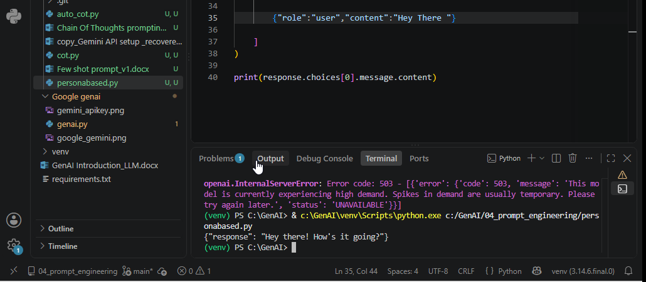

Program:
